## Evidence Search Service Results of your search request

**Update: Guidance and advice for clinicians: ventilators COVID-19 & other patients**

Thank you for requesting this evidence search. We hope you find the results useful. If you would like to discuss the findings or require an additional search, please contact: Alison McLaren [alisonmclaren1@nhs.net](mailto:alisonmclaren1@nhs.net)

Please acknowledge this work in any resulting paper or presentation as: *Evidence search: Update: Guidance and advice for clinicians: ventilators COVID-19 & other patients* Alison McLaren. (10 April 2020). East Surrey Hospital, UK: Surrey and Sussex Library and Knowledge Services.

## Contents

A. National and International Guidance

Scottish Government

Coronavirus (COVID-19): ethical advice and support framework

B. Original Research

1. Code Blue During the COVID-19 Pandemic
2. Editorial: SARS-CoV-2, the Medical Profession, Ventilator Beds, and Mortality Predictions: Personal Reflections of an Australian Clinician
3. Ethics in the time of COVID: What remains the same and what is different
4. Locally Informed Simulation to Predict Hospital Capacity Needs During the COVID-19 Pandemic
5. Public Health and Ethics Intersect at New Levels With Gerontological Nursing in COVID-19 Pandemic

## A. National and International Guidance

#### Scottish Government

**Coronavirus (COVID-19): ethical advice and support framework** (2020)

[Available online at this link](https://www.knowledgeshare.nhs.uk/index.php?PageID=link_resolver&link=a6b4a01e937b0411ff1071a4b68ff66b)

This guidance on ethical advice and support should be read alongside national decision-making and escalation guidance, produced by senior clinical experts, to help to make decisions in difficult circumstances. It applies at all levels of healthcare delivery... In the small number of situations beyond the scope of national guidance or the experience of clinical teams, ethical advice and support must be available to aid decisions at all levels including individual, group or population level.

## B. Original Research

1. **Code Blue During the COVID-19 Pandemic**   
   Chan PS et al Circulation: Cardiovascular Quality and Outcomes 2020;:7 April.

Ahead of print: The surging COVID-19 pandemic has raised ethical and moral dilemmas that Western nations with first-rate medical care facilities rarely confront—how to best allocate standard life-saving medical resources when escalating demand outstrips supply. Sadly, these quandaries are familiar challenges in resource-poor countries. What makes this pandemic notable is that the scope and number of reported cases have been primarily in First World nations, raising questions in some settings about the use of emergency treatments like resuscitation care for in-hospital cardiac arrest (IHCA). This perspective reviews the debate around these ethical and moral dilemmas more broadly but focuses specifically on IHCA and the response of the medical community.

[Available online at this link](https://www.knowledgeshare.nhs.uk/index.php?PageID=link_resolver&link=2e26f2e193fbbcce750fc2ba15a97e45)

1. **Editorial: SARS-CoV-2, the Medical Profession, Ventilator Beds, and Mortality Predictions: Personal Reflections of an Australian Clinician**   
   Talley NJ Medical Journal of Australia 2020;:3 April.

[...] On 26 March we published a new model of COVID‐19‐related mortality and hospital admissions, validated against Italian data.3 The model is simple and grim; it describes a hypothetical Australian hospital admitting new cases of confirmed COVID‐19 infection day after day, assuming that one in 20 patients require intensive care for 10 days, and that the COVID‐19 community case load increases by 20% each day. From day 15 — about the time when it is expected that available ICU beds run out — mortality steadily increases, as has happened in Italy. Those familiar with outbreak modelling know how complex such models can be and how many unknowns need to be imputed, especially early in a new outbreak; some employ supercomputers for their calculations, and can take months or years to build their model. Further, the predictive validity of complex models in an outbreak may not apply in other locations because human behaviour is complex and unpredictable [...]

[Available online at this link](https://www.knowledgeshare.nhs.uk/index.php?PageID=link_resolver&link=5ff7142e1ec7db074016a0f36425a692)

1. **Ethics in the time of COVID: What remains the same and what is different**  
   Scott Y. H. Kim Neurology 2020;April:online.

pdf can be downloaded: The COVID-19 pandemic raises difficult ethical questions for our healthcare system and its providers. Perhaps the most difficult is how to fairly distribute scarce resources, such as ICU beds and ventilators, as the answer will determine who lives and who dies. Compounding the difficulty, all of us are experiencing the dizzying newness of our socially distanced lives, and we sense that ‘things are different now.’ How do our traditional ethical principles apply to these very novel circumstances?

[Available online at this link](https://www.knowledgeshare.nhs.uk/index.php?PageID=link_resolver&link=c30a5e4c7b978039f32687b0948f5c8a)

1. **Locally Informed Simulation to Predict Hospital Capacity Needs During the COVID-19 Pandemic**   
   Weissman GE et al Annals of Internal Medicine 2020;:7 April.

Background: The coronavirus disease 2019 (COVID-19) pandemic challenges hospital leaders to make time-sensitive, critical decisions about clinical operations and resource allocations. Objective: To estimate the timing of surges in clinical demand and the best- and worst-case scenarios of local COVID-19-induced strain on hospital capacity, and thus inform clinical operations and staffing demands and identify when hospital capacity would be saturated. Design: Monte Carlo simulation instantiation of a susceptible, infected, removed (SIR) model with a 1-day cycle. Setting: 3 hospitals in an academic health system. Patients: All people living in the greater Philadelphia region. Measurements: The COVID-19 Hospital Impact Model (CHIME) (http://penn-chime.phl.io) SIR model was used to estimate the time from 23 March 2020 until hospital capacity would probably be exceeded, and the intensity of the surge, including for intensive care unit (ICU) beds and ventilators. Results: Using patients with COVID-19 alone, CHIME estimated that it would be 31 to 53 days before demand exceeds existing hospital capacity. In best- and worst-case scenarios of surges in the number of patients with COVID-19, the needed total capacity for hospital beds would reach 3131 to 12 650 across the 3 hospitals, including 338 to 1608 ICU beds and 118 to 599 ventilators. Limitations: Model parameters were taken directly or derived from published data across heterogeneous populations and practice environments and from the health system's historical data. CHIME does not incorporate more transition states to model infection severity, social networks to model transmission dynamics, or geographic information to account for spatial patterns of human interaction. Conclusion: Publicly available and designed for hospital operations leaders, this modeling tool can inform preparations for capacity strain during the early days of a pandemic.

[Available online at this link](https://www.knowledgeshare.nhs.uk/index.php?PageID=link_resolver&link=225a814840f7b373892dd6980b03e75f)

1. **Public Health and Ethics Intersect at New Levels With Gerontological Nursing in COVID-19 Pandemic**   
   Young HM Journal of Gerontological Nursing 2020;:8 April.

Editorial: [...] The predominant focus of health system readiness has been on ramping up hospital services from more available and rapid testing to caring for critically ill patients on ventilators. Emergency plans are in play for addressing supply chain issues, personnel, surge capacity, and protecting the safety of health care workers. Given the interrelatedness of all health services and the general community, community- and state-level planning are essential to address collective strategies that minimize transmission, expedite care in the appropriate setting, assure adequate human and material resources, and promote physical and mental health in the face of this crisis. Health systems are establishing ethical guidelines allocating scarce resources, particularly in light of the current projected shortage of ventilators and staff to support critically ill patients requiring intubation. Th ese discussions bring to the fore the value of life in the context of distributive justice (White & Lo, 2020). Clinicians face difficult conversations and may require additional preparation for these encounters, such as that provided by VitalTalk, a nonprofit that works to help clinicians communicate better and more compassionately with seriously ill patients and their families (Back et al., 2019). Many hospitals have established policies to limit visitors, many barring all visitors to protect the health and safety of these individuals and to allow staff to focus on prioritizing care. This policy has created tension and sorrow for many caregivers who play such a vital role in supporting older adults' health and well-being, including minimizing adverse effects of hospitalization, such as falls and delirium.

[Available online at this link](https://www.knowledgeshare.nhs.uk/index.php?PageID=link_resolver&link=cea9cec96d56cb691a534bd3cabc4855)

If you would like to request any articles please use our online [request form](http://www.surreyandsussexlibraryservices.nhs.uk/useful-resources/requests/article-request-form/)

For more information about the resources please go to: <http://www.surreyandsussexlibraryservices.nhs.uk>

### Opening Internet Links

The links to internet sites in this document are 'live' and can be opened by holding down the CTRL key on your keyboard while clicking on the web address with your mouse

### Full text papers

Links are given to full text resources where available. For some of the papers, you will need an **NHS OpenAthens Account**. If you do not have an account you can [register online](https://openathens.nice.org.uk/).

You can then access the papers by simply entering your username and password. If you do not have easy access to the internet to gain access, please let us know and we can download the papers for you.

### Guidance on searching within online documents

Links are provided to the full text of each document. Relevant extracts have been copied and pasted into these results. Rather than browse through lengthy documents, you can search for specific words as follows:

**Portable Document Format / pdf / Adobe**  
Click on the Search button (illustrated with binoculars). This will open up a search window. Type in the term you need to find and links to all of the references to that term within the document will be displayed in the window. You can jump to each reference by clicking it.

**Word documents**  
Select Edit from the menu, the Find and type in your term in the search box which is presented. The search function will locate the first use of the term in the document. By pressing 'next' you will jump to further references.

## Search History

Cochrane Library; EMBASE; Google (Advanced); King’s Fund; NICE; Nuffield Council on Bioethics; Nuffield Trust; PubMed; TRIP PRO

**Date range used** (5 years, 10 years):   
**Limits used** (gender, article/study type, etc.):   
**Search terms and notes**: coronavirus - COVID-19 - infectious disease - communicable disease -- pandemic -- ventilator -- ventilated patient* - respiratory -- triage -- predict* -- prioriti?e – survival

**Date of request:** 8th April, 2020  
**Date of completion:** 10th April, 2020

Audience/Context: Clinical Ethics Advisory Committee

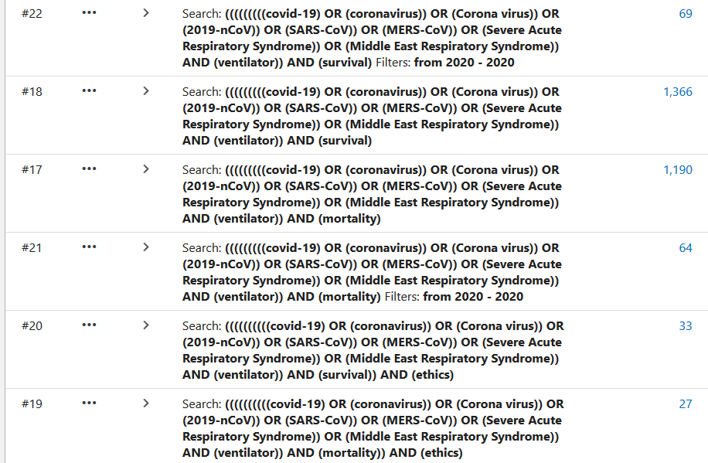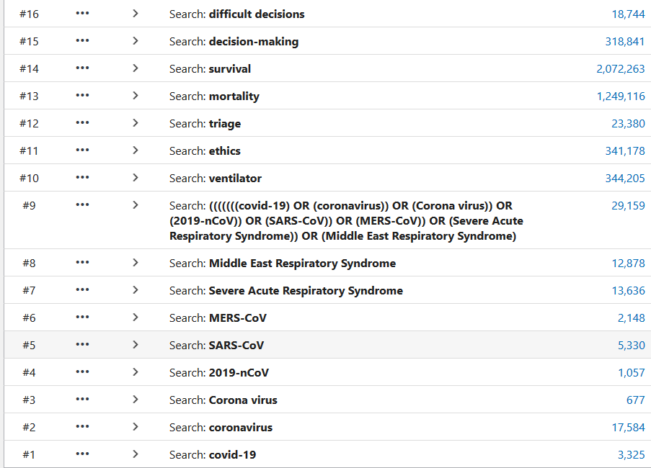

A member of our team will invite you to provide feedback in relation to this search and we look forward to hearing your comments and suggestions for improving our service. Please note that this search has been added to your library record on KnowledgeShare. It is covered by our privacy policy which can be viewed here: <https://www.surreyandsussexlibraryservices.nhs.uk/about/joining-the-library/>

**Disclaimer** Whilst care has been taken in the selection of the materials included in this evidence search, the Library Services are not responsible for the content or the accuracy of the enclosed research information. Accordingly, whilst every endeavour has been undertaken to execute a comprehensive search of the evidence, the Library is not and will not be held responsible or liable for any omissions to pertinent research information not included as part of the results of the enclosed evidence search.